Государственное бюджетное общеобразовательное учреждение
Самарской области средняя общеобразовательная школа с. Тёпловка
муниципального района Пестравский Самарской области

Открытый урок на тему «Мой дорогой дом»
Английский язык
6 класс

Подготовила и провела учитель английского языка
Фисенко Наталья Юрьевна

Повторительно-обобщающий урок по теме «Мой дорогой дом».
Цель: Создание условий для деятельности учащихся, направленной на достижение ими:
1. Предметных результатов:
- активизация лексического материала по теме «Дом. Квартира»;
- активизация грамматических навыков: Оборот There is/are; Present Perfect, Present Indefinite, Past Indefinite;
- совершенствование навыков диалогической речи;
- развитие монологической речи учащихся;
- развитие навыков чтения;
- совершенствование навыков перевода.
2. Метапредметных результатов:
- освоение способов деятельности (познавательной, информационно-коммуникативной, рефлексивной).
3. Личностных результатов:
- использование полученной информации в своей жизни.

УУД
Регулятивные: 1) самостоятельно ставить цели, планировать пути их достижения, умение выбирать наиболее эффективные способы решения учебных и познавательных задач; 2) корректировать свои действия в соответствии с изменяющейся ситуацией.
Познавательные: 1) пользоваться логическими действиями сравнения, анализа, обобщения, классификации по разным признакам; 2) работать с текстовыми материалами; 3) выделять, обобщать и фиксировать нужную информацию.
Коммуникативные: 1) готовность и способность осуществлять общение и вести диалог на английском языке; 2) уметь аргументировать свою точку зрения.
Личностные: 1) проявлять уважительное отношение к партнёрам, внимание к личности другого; взаимопомощь, толерантное отношение друг к другу.

Оснащение: ноутбук, проектор, интерактивная доска, картинки комнат, картинки с предметами мебели. Презентация в Power Point.

Ход урока
Учитель: Дорогие мальчики и девочки! Сегодня мы с вами повторим слова и выражения по теме «Мой дорогой дом».
Teacher: Dear, boys and girls! Today we are going to revise the words and expressions, which we’ve learned.

- Answer my questions. (Показываю слайды с изображением комнат. Дети называют комнату).
- What is this?
- This is a room.
- That’s right. Name the room, please.
- This is a living room. (and so on… a kitchen, a dining room and a bedroom).
- What shall we speak about during this lesson? Can you guess?
- We shall speak about the house.

- Now, let’s describe the house and one of the room. Go to the blackboard and fill in the gaps. Then read and translate your sentence. And all the rest should fill in the gaps in the exercise in your sheets of paper. Интерактивные упражнения There is/ There are. (Дети выходят по одному к доске, выбирают правильный ответ, получают жетон. Неправильный – не получают). (Текст написан у них на листочках. На местах дети пишут в листочках)
Интерактивные упражнения https://learningapps.org/myapps.php

This is the house. There are four rooms in the house. There are all modern conveniences in it. There is central heating, running water, electricity and gas. This is a living-room. There is a wall-unit in the living-room. There is a sofa in front of the wall unit. There are no arm-chairs. There is no table. There is a TV-set on the wall unit. Is there any table in your living room? Are there any arm-chairs in your living room?

- Physical exercises. (a song about the house) Физминутка (Песня про дом) https://www.youtube.com/watch?v=6N7mqIIz6BI

- Задание выбирают по степени сложности сами дети.
So. Here is the text. But the tasks for it are different.
You can choose the task which you think you’ll manage to fulfill. You’ve got 5 minutes. For each right answer of this task you’ll get 1 token. For this task you’ll get 2 tokens. And for this you’ll get 3 tokens.
The task for the first group is to put missing words in the gaps. Remember that there is one extra word.
washed, has watered, work, help, have already swept, tidied up, clean, has done

- We usually ______________ our Mum about the house. 2) Yesterday I ______________ the dishes and ________________ my room. 3) Alice _____________________the flowers today. 4) This week Dad _______________________ the shopping. 5) We often ___________________ the garden, today we ______________________________ the paths there.

The task for the second group. Put the verbs in the Present Simple Tense, The Past Simple Tense or The Present Perfect Tense. Choose from the given variants.
- We usually ______________(help, helped, have helped) our Mum about the house. 2) Yesterday I ______________ (have washed, wash, washed) the dishes and ________________ (have tidied up, tidy up, tidied up) my room. 3) Alice _____________________ (waters, has watered, watered) the flowers today. 4) This week Dad _______________________ (did, does, has done) the shopping. 5) We often ___________________ (clean, have cleaned, cleaned) the garden, today we ______________________________(have already swept, sweep, swept) the paths there.

The pupils of the third group should fill in the gaps with the verbs in the correct form.
- We usually ______________(to help) our Mum about the house. 2) Yesterday I ______________ (to wash) the dishes and ________________ (to tidy up) my room. 3) Alice _____________________ (to water) the flowers today. 4) This week Dad _______________________ (to do) the shopping. 5) We often ___________________ (to clean) the garden, today we ____________________________(to sweep) the paths there.

Now, exchange your sheets of paper and check. The right variant is on the slide.
(Обмениваются тетрадями и проверяют)
Exchange your sheets of paper once more and tell me how many right answers you have got.

Now I need three pairs of pupils. The next task is to make a dialogue from the given phrases. Mind, there are two extra phrases in each dialogue. Then you should read your dialogues. (Дети составляют диалоги из предложенных фраз. В каждой стопке фраз есть 2 лишние фразы)
- Mum, shall I wash the dishes?
-Thank you very much.
- Shall I feed the dog?
- Can you help me?
(после того как дети читают свой диалог, он появляется на слайде)

-Mum, I’ll sweep the floor.
-Oh, thank you.
- Mum, I can do the shopping.
- How do you do.

-Mum, shall I give you a hand? I can clean the kitchen.
-It’s all right, thank you. I’ve already cleaned it.
- Nice to meet you.
- Not at all.
Look at the slide, please. What are these dialogues about? (helping about the house).
Write down one of these dialogues in your papers.

Дети по мере выполнения упражнений заполняют оценочный лист
- Do you like the lesson? (Вам понравился урок?)
- What do you like in it? (Что вам понравилось на уроке?)
- I think, it was useful and interesting. All of this material you can use on our next lesson for making your own project about your house. (Я думаю, он был полезным и интересным. Весь этот материал вы можете использовать на нашем следующем уроке для работы над проектом о своём доме).

All of you worked not bad. Now, count your tokens, that you’ve gained during the lesson. How many tokens have you got? Your marks are…
Thanks everybody.

Учитель английского языка: Фисенко Н.Ю.

Приложение
- Mum, shall I wash the dishes?
-Thank you very much.
- Shall I feed the dog?
- Can you help me?

-Mum, I’ll sweep the floor.
-Oh, thank you.
- Mum, I can do the shopping.
- How do you do.

-Mum, shall I give you a hand? I can clean the kitchen.
-It’s all right, thank you. I’ve already cleaned it.
- Nice to meet you.
- Not at all.
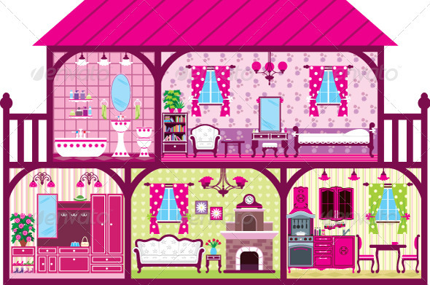
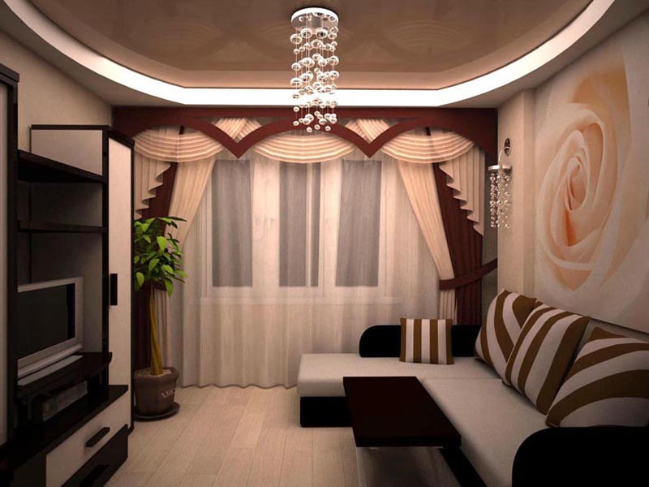
Fill in the gaps with is or are
This is the house. There _______ four rooms in the house. There _______ all modern conveniences in it. There _____ central heating, running water, electricity and gas. This is a living-room. There ________ a wall-unit in the living-room. There _____ a sofa in front of the wall unit. There ______ no arm-chairs. There _____ no table. There ______ a TV-set on the wall unit. _____ there any table in your living room? ______ there any arm-chairs in your living room?

Fill in missing words in the gaps. Remember that there is one extra word.
washed, has watered, work, help, have already swept, tidied up, clean, has done

1) We usually ______________ our Mum about the house. 2) Yesterday I ______________ the dishes and ________________ my room. 3) Alice _____________________the flowers today. 4) This week Dad _______________________ the shopping. 5) We often ________________ the garden, today we ________________________ the paths there.

Put the verbs in the Present Simple Tense, The Past Simple Tense or The Present Perfect Tense. Choose from the given variants.
1)We usually ______________(help, helped, have helped) our Mum about the house. 2) Yesterday I ______________ (have washed, wash, washed) the dishes and ________________ (have tidied up, tidy up, tidied up) my room. 3) Alice _____________________ (waters, has watered, watered) the flowers today. 4) This week Dad _______________________ (did, does, has done) the shopping. 5) We often ___________________ (clean, have cleaned, cleaned) the garden, today we ______________________________(have already swept, sweep, swept) the paths there.

Fill in the gaps with the verbs in the correct form.
1)We usually ______________(to help) our Mum about the house. 2) Yesterday I ______________ (to wash) the dishes and ________________ (to tidy up) my room. 3) Alice _____________________ (to water) the flowers today. 4) This week Dad _______________________ (to do) the shopping. 5) We often ___________________ (to clean) the garden, today we ____________________________(to sweep) the paths there.

Fill in the gaps with is or are
This is the house. There _______ four rooms in the house. There _______ all modern conveniences in it. There _____ central heating, running water, electricity and gas. This is a living-room. There ________ a wall-unit in the living-room. There _____ a sofa in front of the wall unit. There ______ no arm-chairs. There _____ no table. There ______ a TV-set on the wall unit. _____ there any table in your living room? ______ there any arm-chairs in your living room?

Fill in the gaps with is or are
This is the house. There _______ four rooms in the house. There _______ all modern conveniences in it. There _____ central heating, running water, electricity and gas. This is a living-room. There ________ a wall-unit in the living-room. There _____ a sofa in front of the wall unit. There ______ no arm-chairs. There _____ no table. There ______ a TV-set on the wall unit. _____ there any table in your living room? ______ there any arm-chairs in your living room?

Fill in the gaps with is or are
This is the house. There _______ four rooms in the house. There _______ all modern conveniences in it. There _____ central heating, running water, electricity and gas. This is a living-room. There ________ a wall-unit in the living-room. There _____ a sofa in front of the wall unit. There ______ no arm-chairs. There _____ no table. There ______ a TV-set on the wall unit. _____ there any table in your living room? ______ there any arm-chairs in your living room?

